AI Powered Vocal Synthesis Pipeline
CLOUD COMPUTING

Submitted by

AKSHITHA (230701025)
FARHEEN TABASSUM (23070188)
KAAVIYA R (230701504)

in partial fulfilment for the award of the degree of
BACHELOR OF ENGINEERING
in
COMPUTER SCIENCE AND
ENGINEERING
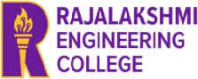


DEPARTMENT OF COMPUTER SCIENCE AND
ENGINEERING
RAJALAKSHMI ENGINEERING COLEGE
APRIL 2026
ANNA UNIVERSITY, CHENNAI

BONAFIDE CERTIFICATE

Certified that this project report titled “AI Powered Vocal Synthesis Pipeline

is the bonafide work of AKSHITHA (230701025)FARHEEN TABASSUM (23070188) KAAVIYA R (230701504)who carried out the work under my supervision. Certified further that to the best of my knowledge the work reported herein does not form part of any other thesis or dissertation on the basis of which a degree or award was conferred on an earlier occasion on this or any other candidate.

SIGNATURE SIGNATURE

Dr. E. M Malathy Dr.M.Ayyadurai
Professor & Supervisor
Head of The Department Associate Professor
Department of Computer Science Department of Computer Science
and Engineering and Engineering
Rajalakshmi Engineering College Rajalakshmi Engineering College

Submitted to Project Viva Voce Examination held on

Internal Examiner External Examiner

ACKNOWLEDGEMENT

Initially we thank the Almighty for being with us through every walk of our life and showering his blessings through the endeavor to put forth this report. Our sincere thanks to our Chairman Mr. S.MEGANATHAN, B.E, F.I.E., our Vice Chairman Mr. ABHAY SHANKAR MEGANATHAN, B.E., M.S., and our respected Chairperson Dr. (Mrs.) THANGAM MEGANATHAN, Ph.D., for providing us with the requisite infrastructure and sincere endeavoring in educating us in their premier institution.
Our sincere thanks to Dr. S.N. MURUGESAN, M.E., Ph.D., our beloved Principal for his kind support and facilities provided to complete our work in time. We express our sincere thanks to Dr.MALATHY E.M, Ph.D., Professor and Head of the Department of Computer Science and Engineering for her guidance and encouragement throughout the project work. We convey our sincere and deepest gratitude to our internal guide, DR. M. AYYADURAI M.E.,Ph.D., Associate Professor, Department of Computer Science and Engineering for his valuable guidance throughout the course of the project.

AKSHITHA
FARHEEN TABASSUM
KAAVIYA R

ABSTRACT

The AI Based Raga and Thala Music Generation System is an intelligent music learning and music generation platform developed to help beginner singers, music learners, and independent artists practice and understand Carnatic music concepts in a modern and interactive manner. Traditional music learning methods require continuous support from teachers, repeated listening sessions, and manual practice. Many learners find it difficult to understand ragas, rhythmic structures, and song formation because of the complexity involved in classical music. This project attempts to solve these problems by using artificial intelligence and cloud-based APIs. The platform allows users to select a raga and thala according to their preference. Based on the selected musical structure, the system automatically generates swaras using the Gemini API. The generated swaras are then processed through a custom thala spacing algorithm implemented in the backend. This logic ensures that notes are aligned properly with beat patterns and rhythmic timing. The system also provides random snippets of songs related to the selected raga and thala combination to help users understand how the musical structure is used in practical songs. The project further integrates the Suno API for AI music generation. When users click the generate option, the platform creates complete music outputs with melody, lyrics, and singing style. This feature is especially useful for beginner singers because they can both read the lyrics and hear how the song should be sung. The project therefore combines theoretical learning with practical audio understanding. The project demonstrates the integration of AI technologies, music theory, cloud computing, rhythm synchronization, and audio generation into a single intelligent ecosytem.

TABLE OF CONTENTS

Chapter No. Title Page No.

1 Introduction |  |  |  |  | 7
1.1 Problem Statement |  |  |  |  | 7
1.2 Objective of the Project |  |  |  |  | 8
1.3 Scope and Boundaries |  |  |  |  | 9
1.4 Stakeholders and End Users |  |  |  |  | 10
1.5 Technologies Used |  |  |  |  | 11
1.6 Organization of the Report |  |  |  |  | 13
2 System Design and Architecture |  |  |  |  | 15
2.1 Requirement Summary (Functional Functional) |  |  | & | Non- | 15
2.2 Proposed Solution Overview |  |  |  |  | 17
2.3 Cloud Deployment Strategy |  |  |  |  | 18
2.4 Infrastructure Requirements |  |  |  |  | 19
2.5 Azure Services Mapping and Justification |  |  |  |  | 20
3 DevOps Implementation |  |  |  |  | 22
 | 3.1 | Continuous Integration and Deployment (CI/CD) Setup |  |  | 22
 | 3.2 | Terraform Infrastructure-as-Code (IaC) |  |  | 24
 | 3.3 | Containerization Strategy (Docker) |  |  | 26
 | 3.4 | Kubernetes Orchestration (AKS Deployment, Scaling) |  |  | 27
 | 3.5 | GenAI Integration and Azure AI Service Mapping |  |  | 29
4 |  | Cloud Operations and Security |  |  | 30
 | 4.1 | DevSecOps Integration (CodeQL / SonarCloud / ZAP Scans) |  |  | 30
 | 4.2 | Monitoring and Observability (Azure Monitor / App Insights) |  |  | 31
 | 4.3 | Access Control (RBAC Overview) |  |  | 32

4.4 Blue–Green Deployment & Disaster Recovery 32 Planning
- Results and Discussion 35
  - Implementation Summary 35
  - Challenges Faced and Resolutions 35
  - Performance or Cost Observations 36
  - Key Learnings and Team Contributions 37
- Conclusion and Future Enhancement 38
  - Conclusion 38
  - Future Scope 38
Appendices 41

CHAPTER 1 - INTRODUCTION

PROBLEM STATEMENT

Traditional music education requires long-term training and direct supervision from teachers. Beginners often struggle with rhythm synchronization, swara understanding, and pronunciation. Existing applications do not provide personalized AI-generated music-learning experiences. Generating musical structures manually is time-consuming and difficult for learners. Additionally, beginner singers need examples of how lyrics should be sung in a specific raga and thala combination. Without such guidance, learners may develop incorrect singing habits. Another challenge is the lack of systems that combine theory and practical singing support together. Most systems only provide notes or audio playback without intelligent generation capabilities. Therefore, there is a need for an intelligent AI-based system capable of generating swaras, maintaining rhythm synchronization, providing song snippets, and creating AI-generated singing outputs for practice and learning. Traditional music education requires long-term training and direct supervision from teachers. Beginners often struggle with rhythm synchronization, swara understanding, and pronunciation. Existing applications do not provide personalized AI-generated music-learning experiences. Generating musical structures manually is time-consuming and difficult for learners. Additionally, beginner singers need examples of how lyrics should be sung in a specific raga and thala combination. Without such guidance, learners may develop incorrect singing habits. Another challenge is the lack of systems that combine theory and practical singing support together. Most systems only provide notes or audio playback without intelligent generation capabilities. Therefore, there is a need for an intelligent AI-based system capable of generating swaras, maintaining rhythm synchronization, providing song snippets, and creating AI-generated singing outputs for practice and learning. Traditional music education requires long-term training and direct supervision from teachers. Beginners often struggle with rhythm synchronization, swara understanding, and pronunciation. Existing applications do not provide personalized AI-generated music-learning experiences. Generating musical structures manually is time-consuming and difficult for learners. Additionally, beginner singers need examples of how lyrics should be sung in a specific raga and thala combination. Without such guidance, learners may develop incorrect singing habits. Another challenge is the lack of systems that combine theory and practical singing support together. Most systems only provide notes or audio playback without intelligent generation capabilities. Therefore, there is a need for an intelligent AI-based system capable of generating swaras, maintaining rhythm synchronization, providing song snippets, and creating AI-generated singing outputs for practice and learning.

1.2 OBJECTIVE OF THE PROJECT
The main objective of the AI Based Raga and Thala Music Generation System is to develop an intelligent music-learning and AI music-generation platform that helps beginner singers, music students, and independent artists understand and practice Carnatic music in a simple and interactive manner. The project combines artificial intelligence, cloud APIs, rhythm synchronization, and music-generation technologies to modernize classical music education.

1. To Provide Raga and Thala Selection Options
One of the primary objectives of the project is to allow users to choose different ragas and thalas according to their musical preferences. In Carnatic music, ragas define the melodic structure while thalas define the rhythmic cycle of the song. The system provides multiple combinations of ragas and thalas so that users can experiment with various musical structures and understand how melody and rhythm work together.This feature improves user interaction and makes music learning more personalized and flexible.

2. To Generate Swaras Automatically Using AI
Another important objective is to automatically generate swaras and note patterns using the Gemini API. Normally, creating swaras manually requires deep musical knowledge and significant practice. The AI system simplifies this process by generating meaningful swara sequences based on the selected raga.This objective helps for us Beginners understand note progression ,Reduce manual effort in composition ,Provide instant musical outputs ,Improve creativity and experimentation The generated swaras follow the melodic characteristics of the chosen raga, making the output musically relevant.

3. To Implement Thala Note Spacing Logic
The project aims to implement a custom thala note spacing algorithm that synchronizes musical notes with rhythmic structures. Rhythm management is one of the most difficult aspects of classical music because every note must align correctly with beat cycles.The spacing logic are Arranges notes according to thala timing ,Maintains beat synchronization ,Handles pauses and note durations ,Improves rhythm consistency ,Creates natural musical flow This objective is important because rhythm synchronization directly affects the quality and realism of generated music.

4. To Provide Random Song Snippets for Learning
The system also aims to provide random snippets of songs related to the selected raga and thala. These snippets act as practical references that help users understand how the chosen musical structure is used in real songs.This objective helps users are Learn through examples Understand singing flow ,Observe melodic patterns, Improve familiarity with ragas ,Practice rhythm alignment Song snippets therefore bridge the gap between theoretical learning and practical understanding.

5. To Generate AI-Based Music Using Suno API
One of the major objectives of the project is to generate complete AI-based songs using the Suno API. The generated output includes melody, rhythm, lyrics, and singing voice.This objective allows users to Hear generated songs instantly , Practice singing with audio guidance, Understand pronunciation and rhythm , Experience AI-generated compositions The Suno API integration transforms the platform from a simple note generator into a complete intelligent music-generation system.

6. To Help Beginner Singers Practice Effectively
The project is specially designed to support beginner singers who often struggle with rhythm, pronunciation, and melody understanding. By providing generated lyrics and audio playback together, the system allows users to practice singing more effectively.

7. To Modernize Classical Music Education Using AI
Another major objective is to modernize traditional music education using artificial intelligence technologies. Classical music learning is usually dependent on manual teaching methods, which may not always be accessible to everyone. The project introduces AI-assisted learning, Automated music generation , Intelligent rhythm processing Interactive learning environments , Cloud-based scalability This makes music education more accessible, efficient, and technologically advanced.

8. To Integrate Cloud APIs and Intelligent Processing
The project also aims to integrate multiple cloud APIs and backend processing systems into a single intelligent platform. APIs such as Gemini and Suno handle AI generation tasks while backend algorithms manage rhythm synchronization and processing.

9. To Build a Scalable Future Music-Learning Platform
The final objective is to create a strong foundation for future AI-powered music-learning systems. Although the current implementation uses trial APIs and an undertrained custom model, the architecture is designed for future scalability.

SCOPE AND BOUNDARIES

The scope of the AI Based Raga and Thala Music Generation System includes the design, development, and implementation of an intelligent music-learning and AI music-generation platform that helps users understand and practice Carnatic music concepts through artificial intelligence and cloud-based technologies. The system mainly focuses on generating swaras, synchronizing rhythms, producing AI-generated music, and supporting beginner singers with practical learning assistance.The project combines frontend interaction, backend processing, AI APIs, and rhythm management logic into a single integrated system. Users can select ragas and thalas dynamically, generate swaras using the Gemini API, and create AI-generated songs using the Suno API. The system also provides random song snippets related to selected musical structures so that users can learn through examples and improve singing practice.
.

STAKEHOLDERS AND END USERS

The success of the AI Based Raga and Thala Music Generation System depends on various stakeholders and end users who interact with, manage, develop, or benefit from the platform. Stakeholders are individuals or groups involved in the development, maintenance, and improvement of the project, while end users are the people who directly use the system for music learning and practice. The project is mainly designed for beginner singers, music learners, and independent artists who want an intelligent and interactive platform for practicing Carnatic music concepts such as ragas and thalas.

TECHNOLOGIES USED
The project incorporates a modern technology stack tailored for AI-based music generation, rhythm synchronization, scalability, cloud integration, and ease of development.
Table 1: Frontend Technologies
Technology | Purpose
React | Used for building the frontend user interface of the music generation platform.
TypeScript | The programming language chosen for frontend development for better type safety and maintainability.
Tailwind CSS | Used for designing responsive and modern user interface components.
HTML5 | Used for structuring web pages and interface elements.
CSS3 | Used for styling and improving the appearance of the application.
JavaScript | Used for frontend interactions and dynamic functionality.
Audio Player | Used for playing generated songs and music snippets.

Table 2: Backend Technologies

Technology | Purpose
Python | Used for backend logic, API communication, and music processing.
Flask / FastAPI | Lightweight backend framework for handling API requests and responses.
Gemini API Integration | Used for generating swaras and musical note structures.
Custom Thala Logic Engine | Used for rhythm synchronization and note spacing management.
PostgreSQL | Relational database used for storing user data and generated music information.
Blob Storage | Used for storing generated audio files and music outputs.
REST APIs | Used for communication between frontend and backend services.

Table 3: Cloud and Infrastructure

Technology | Purpose
Microsoft Azure | Primary cloud platform used for hosting and managing services.
Azure Functions | Used for serverless AI processing and music generation tasks.
Azure Storage Account | Used for storing generated music files and audio data.
Azure Container Apps | Used for scalable deployment and container orchestration.
Azure PostgreSQL Flexible Server | Managed database service for storing structured application data.
Docker | Used for containerizing backend applications and APIs.
Terraform | Used for Infrastructure as Code (IaC) provisioning and automation.
Cloud APIs | Used for scalable AI-based processing and cloud integration.

Table 4: AI and Machine Learning Technologies
Technology | Purpose
Google Gemini Pro API | Used for generating swaras and musical note structures based on ragas.
Suno API | Used for AI-based music generation, melody creation, and singing output generation.
AI Prompt Engineering | Used for constructing intelligent prompts for music generation.
Machine Learning Models | Used for future custom singing model training and audio synthesis.
Rhythm Synchronization Algorithms | Used for thala note spacing and beat alignment.

Table 5: DevOps and CI/CD Technologies

Technology | Purpose
GitHub Actions | Used for automating workflows, builds, and deployments.
Docker Hub | Used as a container registry for storing and distributing Docker images.
Azure CLI | Used for command-line management of Azure resources and services.
Git | Used for version control and collaborative development.
CI/CD Pipelines | Used for automated integration, testing, and deployment.

Table 6: Audio and Music Technologies

Technology | Purpose
Audio Processing Libraries | Used for handling audio playback and synchronization.
Music Generation APIs | Used for generating AI-based musical outputs.
Thala Spacing Algorithms | Used for rhythm management and beat synchronization.
Singing Voice Synthesis | Used for AI-generated singing outputs.
Song Snippet Generator | Used for generating random musical references for learning.

ORGANIZATION OF THE REPORT

This report is organized to provide a complete and systematic documentation of the development, implementation, and future scope of the AI Based Raga and Thala Music Generation System. The report explains the integration of artificial intelligence, rhythm synchronization, cloud APIs, and music generation technologies into a single intelligent music-learning platform.

Chapter 1 – Introduction
The overall background and motivation behind the project. It explains the importance of ragas and thalas in classical music and discusses the challenges faced by beginner singers during music learning. This chapter also includes the problem statement, objectives of the project, scope and boundaries, stakeholders and end users, technologies used, and the organization of the report structure.

Chapter 2 – System Design and Architecture
It describes the frontend and backend workflow, API communication, cloud integration, and rhythm synchronization process. The chapter explains the working architecture of the Gemini API, Suno API, custom thala note spacing logic, and music-generation workflow. It also includes infrastructure requirements and system flow descriptions.

Chapter 3 – Implementation and AI Integration
It explains how the frontend interface, backend processing modules, and AI services were developed and integrated. The chapter discusses swara generation using Gemini API, AI music generation using Suno API, custom rhythm synchronization algorithms, and random song snippet generation. It also explains backend logic, API communication methods, and audio playback integration.

Chapter 4 – Cloud Deployment and DevOps
It explains the cloud infrastructure, deployment process, and DevOps practices used in the project. It discusses containerization using Docker, Infrastructure as Code using Terraform, and deployment using Microsoft Azure services. The chapter also explains CI/CD automation using GitHub Actions, cloud scalability, serverless execution, and future GPU-based model hosting possibilities.

Chapter 5 – Results and Discussion
It presents the implementation results and discusses the overall performance of the system. It explains the successful generation of swaras, rhythm synchronization, random song snippets, and AI-generated music outputs. The chapter also discusses challenges faced during development, including audio model underfitting, rhythm synchronization difficulties, API limitations, and processing delays. Performance observations and future improvements are also included.

Chapter 6 – Conclusion and Future Enhancements
concludes the report by summarizing the achievements and contributions of the project. It explains how the system successfully integrates AI technologies with classical music learning and supports beginner singers through intelligent music generation. The chapter also presents future enhancement plans such as custom singing model training, Azure cloud integration, real-time voice correction, multilingual support, and advanced rhythm analysis systems.
.

CHAPTER 2 - SYSTEM DESIGN AND ARCHITECTURE

REQUIREMENT SUMMARY

Functional Requirements
The AI Based Raga and Thala Music Generation System consists of multiple AI-powered, cloud-integrated, and music-processing components designed to provide scalable, interactive, and intelligent music-learning support for users.The frontend of the application will be developed using React and TypeScript to provide a responsive and user-friendly interface for music learners and singers. The frontend will be hosted using Microsoft Azure Static Web Apps, enabling reliable hosting, fast loading speed, and cloud scalability with minimal operational cost.
The system allows users to select ragas and thalas dynamically through the frontend interface. Based on the selected musical structure, the backend communicates with the Google Gemini Pro API to generate swaras and melodic note sequences. These generated swaras are then processed using custom thala note spacing logic implemented within the backend system to maintain rhythm synchronization and beat alignment.
For backend services, the platform uses Python-based APIs deployed through Docker containers for lightweight and secure deployment. The backend services are hosted using Azure Container Apps to support scalable processing for swara generation, rhythm synchronization, AI music requests, and audio management. The estimated monthly operational cost for backend hosting and processing is approximately ₹2,500 to ₹3,000.
The platform also integrates the Suno API for AI-based song generation. When users select the generate music option, the backend sends prompts and musical structure information to the Suno API, which generates melody, lyrics, and singing outputs for practice purposes.
Generated songs, random song snippets, and user-uploaded audio files are stored using Azure Blob Storage with geo-redundant storage capability. This allows secure and scalable storage of music-related media files. The estimated storage requirement is approximately 10GB, with a monthly cost of around ₹200.
The application uses Azure PostgreSQL Flexible Server as the primary relational database system for storing user information, selected ragas, thala configurations, generated outputs, and application metadata. The database configuration includes 1 vCore and scalable storage support, with an estimated cost of ₹1,200 per month.
The system also includes random song snippet generation functionality. Based on selected ragas and thalas, the backend dynamically retrieves or generates short song examples that help users understand practical melodic and rhythmic usage.
Continuous integration and deployment pipelines are automated using GitHub Actions integrated with Azure services. This enables automated testing, container deployment, backend updates, and frontend publishing without additional operational costs.For safety and content filtering, the platform can integrate Azure Content Safety API to detect inappropriate lyrics or unsafe generated content during music-generation processes. The project mainly uses free-tier API limits during development and testing phases.
The system also supports AI-assisted singing practice by allowing users to hear generated songs while simultaneously reading lyrics. This functionality improves rhythm understanding, pronunciation, and self-learning capability for beginner singers.
Future versions of the system aim to support custom-trained singing models hosted on third-party GPU servers integrated with Microsoft Azure cloud infrastructure for scalable AI audio processing.

Non-Functional Requirements
The AI Based Raga and Thala Music Generation System is designed to satisfy several non-functional requirements that ensure performance, scalability, reliability, security, maintainability, and cost efficiency.
To achieve high performance, the platform targets frontend page loading times below 3 seconds and API response times below 500 milliseconds for swara generation requests. Audio generation processes may require longer durations because AI-based music synthesis is computationally intensive. Azure Static Web Apps combined with cloud-based CDN support ensure faster delivery of frontend resources and static assets.
The system is designed to support scalability for multiple concurrent users through Azure Container Apps with auto-scaling capabilities. This allows the platform to dynamically increase processing resources during high-demand situations such as simultaneous music-generation requests.
For reliability and availability, the application uses Azure cloud infrastructure with SLA-backed services to ensure approximately 99.9% uptime. This minimizes downtime and improves accessibility for music learners and users.
Security is maintained through secure API communication, encrypted cloud storage, authentication mechanisms, and protected backend services. Sensitive API keys and cloud credentials are securely managed using Azure Key Vault and protected environment variables.
Data durability and backup protection are implemented using geo-redundant Azure Blob Storage and managed PostgreSQL backup services. This ensures generated songs, user information, and application configurations remain protected against accidental loss or server failures.
The project architecture follows a modular microservice-oriented structure, which improves maintainability and future scalability. Backend APIs, frontend services, AI modules, and cloud storage systems are separated logically, enabling easier updates and feature expansion.
The platform is also designed for usability and accessibility. The user interface provides simple navigation, beginner-friendly controls, and interactive music-generation options that make the system easy to use even for non-technical users.
For maintainability and deployment automation, GitHub Actions and Docker-based CI/CD pipelines are used to simplify application updates, testing, and deployment processes. This reduces manual configuration effort and improves deployment consistency.
Cost efficiency is another important non-functional requirement of the project. The application is optimized to operate within a student-friendly cloud budget using Azure Student Subscription benefits. The estimated operational expense for development and testing phases is approximately ₹4,000 to ₹5,000 per month while still supporting enterprise-grade cloud capabilities and AI integrations.
Finally, the system is designed for future extensibility. The architecture supports future integration of advanced singing models, real-time voice correction, multilingual lyric generation, personalized music recommendations, and GPU-based audio model hosting without requiring major redesign of the existing system architecture.

2.2 PROPOSED SOLUTION OVERVIEWS

The proposed solution is an AI-powered, cloud-integrated music-learning and music-generation platform designed to support beginner singers, music learners, and independent artists through intelligent swara generation, rhythm synchronization, and AI-generated singing outputs. The system follows a modular and scalable architecture that separates frontend interaction, backend processing, AI services, and cloud storage components to achieve flexibility, maintainability, and efficient performance. At the presentation layer, the platform uses a React and TypeScript-based frontend interface that provides users with an interactive and user-friendly experience. Through this interface, users can select ragas and thalas, generate swaras, access random song snippets, and create AI-generated songs for singing practice. The frontend is hosted using Microsoft Azure Static Web Apps, ensuring reliable cloud-based deployment, fast content delivery, and scalable accessibility. The frontend communicates with a Python-based backend API deployed using Azure Container Apps. The backend is responsible for handling all core application functionalities, including user interaction processing, swara generation requests, rhythm synchronization logic, song snippet generation, audio handling, and AI service orchestration. The backend integrates with the Google Gemini Pro API to generate swaras and melodic note structures based on the selected raga. Once the swaras are generated, the backend applies custom thala note spacing logic to synchronize musical notes according to rhythmic beat cycles and timing intervals. This rhythm-processing module ensures that generated music follows proper thala alignment and natural musical flow.
The system also integrates the Suno API for AI-based song generation. When users select the generate music option, the backend sends prompts containing musical structure information, swaras, rhythm patterns, and lyrical context to the Suno API. The API then generates melody, singing voice, and complete music outputs that users can hear and use for practice purposes. Generated songs, audio snippets, and music-related media are stored using Azure Blob Storage with geo-redundant storage capability for durability and scalability. Structured application data such as user information, selected ragas, generated outputs, rhythm configurations, and metadata are stored using Azure PostgreSQL Flexible Server.
Artificial intelligence services are integrated throughout the system to improve automation and intelligent learning support. The Gemini API handles swara generation, while the Suno API manages music and singing generation. Future versions of the project aim to integrate custom-trained singing models hosted on third-party GPU servers connected through Microsoft Azure cloud infrastructure. For deployment and infrastructure automation, the system uses Docker-based containerization combined with Terraform Infrastructure as Code (IaC). This approach ensures reproducible deployments, simplified cloud management, and scalable service orchestration.
Continuous integration and deployment processes are automated using GitHub Actions integrated with Azure services. This pipeline automates building, testing, container deployment, backend updates, and frontend publishing, ensuring reliable and efficient development workflows. The overall architectural approach combines artificial intelligence, cloud computing, music-generation APIs, rhythm synchronization algorithms, and scalable deployment technologies to create a modern intelligent ecosystem for music education and AI-assisted singing practice.

2.3CLOUD DEPLOYMENT STATERGY
The deployment strategy leverages Microsoft Azure as the primary cloud provider, utilizing a combination of Platform-as-a-Service and Container-as-a-Service models to ensure scalability, flexibility, and efficient cloud management. The frontend application developed using React and TypeScript is deployed on Azure Static Web Apps, enabling fast and reliable hosting with integrated CDN support for improved performance. The selected deployment region is Southeast Asia (Singapore) because it provides lower latency and better accessibility for the target users.
The backend services are deployed using Azure Container Apps with Docker-based containerization to support lightweight, secure, and scalable deployment. These backend services handle swara generation, thala note spacing logic, random song snippet generation, API communication, and AI music orchestration. Azure PostgreSQL Flexible Server is used for storing structured data such as user information, selected ragas, generated swaras, and song metadata, while Azure Blob Storage is used for storing generated songs, audio files, and music-related media content.
Artificial intelligence services are integrated through Google Gemini Pro API and Suno API. The Gemini API is responsible for generating swaras and melodic note structures based on selected ragas, while the Suno API generates AI-based songs, melodies, and singing outputs for practice purposes. The infrastructure is managed using Terraform Infrastructure as Code (IaC), and GitHub Actions automates the build, test, and deployment process, ensuring reliable CI/CD workflows and efficient cloud deployment.

INFRASTRUCTURE REQUIREMENTS

Compute Resources:
• Azure Container Apps: Backend services deployed with Docker containers using 0.25 vCPU and 0.5 GiB memory, with auto-scaling support from 0 to 10 replicas based on API requests and processing load.
• Azure Functions: Consumption plan (Y1 tier) used for lightweight serverless processing tasks such as AI request handling and future music-processing operations. .
• Frontend Hosting: React and TypeScript frontend deployed using Azure Static Web Apps for fast and scalable content delivery.

Storage Requirements:
• Azure PostgreSQL Flexible Server: Used for storing user information, selected ragas, generated swaras, thala configurations, and application metadata with 32 GB storage and automated backups.
• Azure Blob Storage: Hot tier storage with geo-redundant storage support for storing generated songs, audio outputs, music snippets, and media files with an estimated initial capacity of 100 GB.
AI and Processing Requirements:
• Google Gemini Pro API: Used for generating swaras and melodic note structures based on selected ragas.
• Suno API: Used for AI-based music generation, melody creation, and singing output generation.

AZURE SERVICES MAPPING AND JUSTIFICATION

Table 6: Service Mapping
Requirement | Azure Service / Technology | SKU / Tier | Purpose | Justification | Est. Monthly Cost (₹)
Frontend Hosting | Azure Static Web Apps | Standard | Host responsive music-learning frontend | Fast hosting, SSL, CDN integration | Free (Student Credit)
Backend Logic & APIs | Azure Container Apps | 0.75 vCPU, 1.5GB | Host swara generation, rhythm logic, and API services | Scalable containerized backend deployment | 3000
Database | Azure PostgreSQL Flexible Server | 1 vCore, 5GB | Store user data, ragas, thalas, swaras, and metadata | Reliable managed relational database | 1200
Audio & Media Storage | Azure Blob Storage | Hot Tier, Geo-Redundant Storage | Store generated songs, audio snippets, and media files | Cost-efficient and scalable storage | 300
AI Swara Generation | Google Gemini Pro API | Pay-per-use | Generate swaras and melodic note structures | Intelligent AI-based music processing | 100
AI Music Generation | Suno API | Trial / Pay-per-use | Generate AI songs, melodies, and singing outputs | Supports beginner singing practice | 200
Rhythm Synchronization | Custom Thala Logic Engine | Backend Service | Handle note spacing and beat alignment | Maintains proper thala synchronization | 0
Monitoring & Logs | Azure Monitor + Application Insights | Standard | Monitor backend APIs and cloud services | Improves reliability and maintenance | 400
CI/CD Automation | GitHub Actions | Basic | Automate build, testing, and deployment workflows | Seamless GitHub and Azure integration | Free (Student Credit)
Containerization | Docker | Community Edition | Containerize backend services | Lightweight and portable deployment | Free
Infrastructure Automation | Terraform | Open Source | Manage cloud infrastructure deployment | Reproducible Infrastructure as Code | Free

CHAPTER 3 - DEVOPS IMPLEMENTATION

3.1 CONTINUOUS INTEGRATION AND DEPLOYMENT STRATEGY
The project uses a CI/CD pipeline built with GitHub Actions to automate the build, testing, and deployment process. The deployment workflow uses containerization and Infrastructure as Code (IaC) to manage cloud resources and application services efficiently across Microsoft Azure.
The pipeline follows a 2-stage deployment pattern:
Backend Deployment – Deploys backend APIs, swara generation services, and rhythm synchronization logic using Azure Container Apps.
Frontend Deployment – Builds and deploys the React frontend application using Azure Static Web Apps.
The deployment workflow is automatically triggered whenever code is pushed to the main branch or manually triggered through GitHub Actions workflow dispatch.

Pipeline Stages in Detail

Stage 1: Backend Deployment (build-and-deploy-backend)

- Container build and versioning
A unique version tag is generated using the current date and GitHub commit ID. Docker images are built and pushed to the container registry for deployment.
- Infrastructure as code(IAC)
Terraform is used to provision and manage Azure resources such as Container Apps, Blob Storage, PostgreSQL Flexible Server, and monitoring services.
- Azuredeployment:
Secure authentication with Azure is handled using Service Principal credentials stored as GitHub Secrets. Backend containers are deployed to Azure Container Apps with rolling update support to minimize downtime.
- Health check and Validations:
After deployment, automated health checks are performed against backend API endpoints to ensure swara generation services, thala logic processing, and API communication are functioning correctly before completing deployment.

Stage 2: Frontend Deployment (build-and-deploy-frontend)
- Dynamic API Configuration:
The deployed backend API URL is automatically injected into the frontend build configuration to ensure correct API communication.
- Frontend Build and Deployment:
The optimized React and TypeScript frontend application is built and deployed to Azure Static Web Apps for fast and scalable hosting.
- Static Content Delivery:
Azure CDN integration ensures efficient delivery of frontend resources, audio controls, and music-learning interface components.
Table 7. List of Github Secrets

S.No | GitHub Secret
1 | AZURE_CLIENT_ID
2 | AZURE_CLIENT_SECRET
3 | AZURE_SUBSCRIPTION_ID
4 | AZURE_TENANT_ID
5 | AZURE_STATIC_WEB_APPS_API_TOKEN
6 | AZURE_STORAGE_ACCOUNT_NAME
7 | DB_PASSWORD
8 | DOCKERHUB_USERNAME
9 | DOCKERHUB_TOKEN
10 | GEMINI_API_KEY
11 | SUNO_API_KEY
12 | POSTGRES_CONNECTION_STRING
13 | APPLICATION_INSIGHTS_KEY
14 | TERRAFORM_STATE_KEY

TERRAFORM INFRASTRUCTURE-AS-CODE (IaC)

The Terraform code is organized using a standard three-file structure:
- main.tf: Contains the primary definitions for all Azure cloud resources and deployment services.
- variables.tf: Stores configurable input values such as resource names, API keys, storage names, and deployment locations.
- outputs.tf: Defines outputs such as backend API URLs, storage endpoints, and database hostnames for use in CI/CD workflows and frontend configuration.

Core Infrastructure Components
The Infrastructure as Code (IaC) setup provisions and organizes all required cloud services within a centralized Azure Resource Group such as rg-ai-music-dev. The deployment architecture includes frontend hosting, backend APIs, AI integrations, storage services, and database infrastructure required for the AI Based Raga and Thala Music Generation System.

Backend and Container Orchestration

Container App Environment
The Terraform configuration provisions a managed Azure Container App Environment (cae-ai-music-dev) that hosts the backend microservices responsible for swara generation, rhythm synchronization, API communication, and AI orchestration. The environment supports auto-scaling and secure networking for containerized backend services.

Container App
The backend application (ca-ai-music-backend-dev) is deployed as an Azure Container App with the following configurations:
- Scaling: Supports scale-to-zero for cost optimization with auto-scaling up to 10 replicas based on API load and processing requirements.
- Configuration: Database connection strings, Gemini API keys, Suno API keys, and storage endpoints are dynamically configured through environment variables.
- Deployment: Docker container images are automatically deployed through CI/CD pipelines.

Database and Storage

Azure PostgreSQL Flexible Server
Terraform provisions the PostgreSQL Flexible Server (psql-ai-music-dev) used for storing user data, selected ragas, generated swaras, thala configurations, generated songs, and application metadata. The database is configured with PostgreSQL version 13 and cost-efficient burstable performance tier (B_Standard_B1ms).

Azure Blob Storage
A dedicated Blob Storage container is provisioned for storing generated songs, audio outputs, practice snippets, and music-related media files. The storage uses Hot Tier access with geo-redundant storage support for scalability and durability.

Serverless Functions and AI Services

Azure Function App
Terraform provisions the Azure Function App (func-ai-music-dev) used for lightweight AI-processing tasks, metadata generation, and future real-time music-processing features.

Runtime Configuration
The Function App is configured to use the Python 3.9 runtime environment for handling AI request preprocessing and backend utility services.

AI Integration
The infrastructure supports integration with:
- Google Gemini Pro API for swara and melodic note generation.
- Suno API for AI-generated music, melody, and singing outputs.
- Future GPU-based custom singing models connected through Azure infrastructure.

CI/CD Integration
The Terraform configuration is fully integrated with the GitHub Actions CI/CD pipeline. During deployment:
- Required secrets such as database passwords, API keys, and Azure credentials are securely passed from GitHub Secrets into Terraform variables.
- The latest Docker container image tag generated during the build process is automatically passed to the Azure Container App deployment configuration.
- Infrastructure outputs such as Backend API URL, Blob Storage Endpoint, and Database Hostname are captured in outputs.tf and used by later deployment stages including frontend configuration and API communication setup.

CONTAINERIZATION STRATERGY (DOCKER)

The project uses a structured containerization strategy to package the backend services of the AI Based Raga and Thala Music Generation System into lightweight, secure, and scalable Docker images. This approach ensures reliable deployment and efficient execution on Azure Container Apps while supporting AI integrations, swara generation, rhythm synchronization, and music-processing services.

Image Build Process: Multi-Stage Optimization
The backend services use a multi-stage Docker build process to reduce image size and improve deployment efficiency. This separates the build environment from the runtime environment.

Builder Stage
The build process starts with a Python-based image such as python:3.9-alpine. Required dependencies, API libraries, backend frameworks, and music-processing modules are installed during this stage. Backend source code responsible for swara generation, thala note spacing logic, API orchestration, and AI integration is then prepared for deployment.

Runtime Stage
The final runtime stage uses a lightweight Alpine-based image to minimize container size and improve security. Only the required backend files, dependencies, and runtime libraries are copied from the builder stage. This reduces unnecessary packages and optimizes container startup performance.

Deployment, Scaling, and Versioning

1. Azure Container Apps Setup

Resource Allocation
Each backend container instance is configured with:
- 0.25 vCPU
- 0.5 GiB memory
This configuration provides sufficient resources for API processing, swara generation, rhythm synchronization, and AI request handling.

Auto-Scaling
Azure Container Apps support automatic scaling based on API requests and processing load:
- Minimum replicas: 0 (scale-to-zero for cost optimization)
- Maximum replicas: 10
This allows the application to reduce resource consumption during low traffic periods and scale dynamically during heavy AI music-generation requests.

Secure Ingress
External access is enabled through HTTPS-only secure ingress configuration to ensure encrypted API communication and secure frontend-backend interaction.

2. Docker Image Versioning and Deployment
Docker images are automatically built and pushed to Docker Hub through GitHub Actions during the CI/CD workflow. The project follows a clear versioning strategy for backend deployment.
- The latest tag is used for development and testing environments.
- Unique immutable version tags such as vYYYYMMDD- are generated for production deployments.
This versioning strategy improves deployment tracking, rollback management, and release consistency across Azure cloud environments.

KUBERNETES ORCHESTRATION
Azure Kubernetes Service (AKS) is planned for advanced container orchestration and future large-scale deployment of the AI Based Raga and Thala Music Generation System. Kubernetes orchestration provides improved scalability, workload management, high availability, and secure deployment for AI-based music-processing services.

1. Cluster and Deployment Design

Cluster Structure
The AKS cluster follows a multi-node architecture with separate system and user node pools using Azure CNI networking. The cluster supports Cluster Autoscaler functionality to dynamically manage node capacity based on AI processing load, backend API traffic, and music-generation requests.

Workload Deployment
The backend services responsible for swara generation, thala note spacing logic, rhythm synchronization, API orchestration, and AI music generation are deployed as Kubernetes Deployments within a dedicated namespace such as ai-music-app. Standard Kubernetes liveness and readiness probes are configured using backend health-check endpoints to ensure service reliability.

Ingress and Traffic Management
External traffic is managed through an Ingress Controller such as NGINX Ingress Controller. The ingress configuration handles TLS termination and enforces HTTPS-only secure communication between frontend and backend services.

Configuration and Secret Management
Non-sensitive configuration values are managed using ConfigMaps, while sensitive credentials such as Gemini API keys, Suno API keys, database passwords, and Azure credentials are securely managed using Azure Key Vault integrated through the Secrets Store CSI Driver.

2. Scaling, Resilience, and Security

Pod Scaling
The Horizontal Pod Autoscaler (HPA) automatically scales backend pods based on CPU utilization and API request load. Target utilization thresholds such as 60% CPU usage are used for dynamic scaling.

Node Scaling
The Kubernetes Cluster Autoscaler automatically increases or decreases the number of worker nodes depending on backend workload requirements and AI music-generation demand.

Resilience and Availability
Rolling update deployment strategies are configured using:
- maxSurge: 25%
- maxUnavailable: 0
This ensures zero-downtime deployment during backend updates and service upgrades.

Security
Kubernetes security policies, HTTPS-only ingress rules, secure secret management, and isolated namespaces are used to protect backend APIs, AI integrations, database connections, and user-related data within the deployment environment.

GENAI INTEGRATION AND AZURE AI SERVICE MAPPING

AI-Based Swara Generation (Google Gemini Pro API)
This feature uses the Google Gemini Pro API to automatically generate swaras and melodic note structures based on the selected raga and thala combination.

Implementation:
The AI integration is handled through dedicated backend services deployed on Azure Container Apps. This architecture allows swara generation workloads to scale independently from frontend operations and improves AI processing efficiency.

Process:
The user selects a raga and thala through the frontend interface.
The backend constructs a structured prompt containing musical instructions, raga information, and required swara format.
The request is sent to the Google Gemini Pro API.
The API generates swaras and melodic note sequences based on the provided musical structure.
The generated output is returned to the backend for rhythm synchronization and further music processing.
The generated swaras are designed to follow the melodic characteristics and musical patterns of the selected raga.

2. AI Music Generation (Suno API)
This feature uses the Suno API to generate AI-based songs, melodies, and singing outputs for beginner singing practice and music learning.

Implementation:
The Suno API integration is managed through backend orchestration services deployed within Azure Container Apps. The backend coordinates swara generation, lyrical prompts, rhythm synchronization, and music-generation requests before communicating with the API.

Process:
Users click the Generate Music option after swara generation.
The backend prepares prompts containing swaras, rhythm patterns, lyrical context, and musical instructions.
The request is sent to the Suno API for AI music generation.
The API generates melody, singing voice, and complete audio outputs.
Generated songs are stored in Azure Blob Storage and returned to the frontend for playback and practice.
This integration helps beginner singers understand pronunciation, rhythm flow, and melodic singing patterns.

3. Rhythm Synchronization and Thala Logic Processing
The project includes a custom thala note spacing engine that synchronizes generated swaras according to rhythmic beat cycles and timing intervals.

Implementation:
The rhythm-processing module is implemented within backend services and works alongside the AI-generated swara outputs.

Process:
Generated swaras are received from the Gemini API.
The backend applies custom thala note spacing logic based on the selected rhythmic structure.
Notes are aligned according to beat intervals and timing rules.
Rhythm-corrected outputs are passed to the music-generation workflow.
This synchronization process ensures proper beat alignment and natural musical flow in generated songs.

CHAPTER 4 - CLOUD OPERATIONS AND SECURITY

DEVSECOPS INTEGRATION
Security is integrated throughout the development lifecycle of the AI Based Raga and Thala Music Generation System using lightweight, automated, and enforceable security practices. Static code analysis and linting tools are used across both frontend and backend services to identify coding issues, unsafe patterns, and configuration problems before deployment. ESLint with TypeScript support is used for the React frontend, while Python linting and validation tools are used for backend API services handling swara generation, rhythm synchronization, and AI integrations.
Code quality and maintainability are enforced through strict linting configurations and automated validation checks. In the frontend, ESLint rules prevent issues such as unused variables, unsafe component handling, improper API usage, and weak typing practices that may create security risks. In the backend, Python validation and linting tools detect missing error handling, unsafe API requests, configuration issues, and improper environment variable usage. These security checks run locally during development and automatically within GitHub Actions CI/CD workflows, ensuring that insecure code does not reach production environments.
Container security is improved through Docker multi-stage builds and lightweight runtime images. Backend services are packaged using optimized Alpine-based Docker images to minimize unnecessary packages and reduce the container attack surface. Sensitive configurations such as Gemini API keys, Suno API keys, database credentials, and Azure service connections are managed securely through environment variables and GitHub Secrets rather than hardcoded values. Secure HTTPS-only communication, restricted CORS policies, and protected API endpoints are also implemented to improve application security and prevent unauthorized access.
Together, these DevSecOps practices provide continuous security validation, secure deployment management, reduced container vulnerabilities, and secure-by-default cloud configuration while maintaining efficient CI/CD workflows and low operational overhead for the AI-powered music-generation platform.
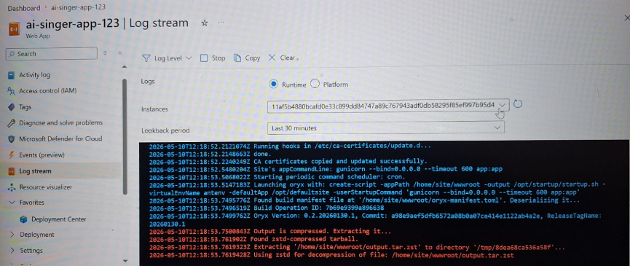
Figure 1. Github Actions Workflow

MONITORING AND OBSERVABILITY
Comprehensive monitoring and observability for the AI Based Raga and Thala Music Generation System are achieved through integration with Azure Monitor and Application Insights. These services provide centralized monitoring, real-time telemetry collection, performance tracking, and operational visibility across frontend applications, backend APIs, Azure Container Apps, database services, and AI integrations. Telemetry data is continuously collected from all Azure resources involved in swara generation, rhythm synchronization, and AI music-processing workflows.
Azure Monitor dashboards are used as the primary visualization layer for tracking system performance and cloud resource health. Metrics collected from Azure Container Apps include CPU utilization, memory usage, API request count, response time, replica scaling activity, and backend health-check status. Real-time dashboards allow developers to monitor frontend responsiveness, AI request processing, swara generation workloads, and music-generation service performance across different deployment environments.
Alerting rules are configured using Azure Monitor to notify developers through email alerts whenever critical thresholds are exceeded. Examples include CPU utilization exceeding 85%, repeated backend API failures, increased response latency during AI music generation, or abnormal container restart frequency. These alerts help the development team quickly identify operational issues and maintain reliable service availability.
Log Analytics Workspace is used to aggregate logs from backend APIs, Azure Container Apps, AI integration services, and database operations into a centralized environment. Logs are analyzed using Kusto Query Language (KQL) to detect operational issues, unusual API traffic, failed AI requests, and repeated server-side errors. Log retention policies ensure monitoring and diagnostic data remain available for future troubleshooting, performance analysis, and security auditing purposes.
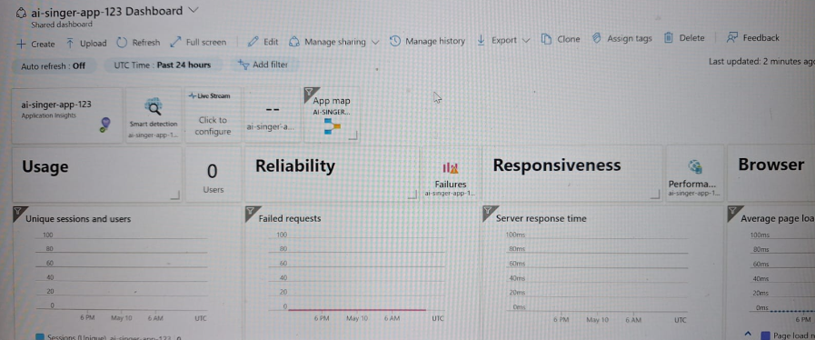
Figure 1.2. Grafana Dashboard

ACCESS CONTROL
Access control in the AI Based Raga and Thala Music Generation System is implemented using secure authentication practices, role-based cloud permissions, and protected API communication. At the Azure infrastructure level, Role-Based Access Control (RBAC) is used to manage access to cloud resources. GitHub Actions deployment workflows use a Service Principal with restricted Contributor access limited to the project resource group, while developers are provided Reader-level access for monitoring and troubleshooting activities.
Application-level security is managed through secure API communication and environment-based authentication mechanisms. Sensitive operations such as swara generation, AI music generation, and backend API access require authenticated requests and protected API keys. Frontend requests communicate securely with backend services through HTTPS-only endpoints, while API validation middleware ensures proper request authorization before processing music-generation operations.
Database credentials, Gemini API keys, Suno API keys, Azure service credentials, and storage access information are securely managed through GitHub Secrets and environment variables instead of hardcoded configurations. Azure PostgreSQL Flexible Server connections enforce secure SSL-based communication, while Azure Container Apps ingress rules restrict unnecessary public exposure. Blob Storage access is also controlled to ensure secure storage and retrieval of generated songs, audio files, and music-related media content.

BLUE–GREEN DEPLOYMENT & DISASTER RECOVERY PLANNING

The deployment strategy follows a near blue–green deployment pattern using Azure Container Apps with controlled revision-based traffic management. Each backend release generates a new Docker container image through the CI/CD pipeline and deploys it as a new application revision. Backend health checks validate API functionality, swara generation services, and rhythm synchronization endpoints before production traffic is routed to the updated version. Traffic is shifted only after successful validation, ensuring near zero-downtime deployment.
Zero-downtime deployment is achieved through rolling updates, container health probes, and revision-based deployment management. Backend services expose a /health endpoint that Azure Container Apps continuously monitor to validate application readiness. Versioned Docker images generated during CI/CD workflows are stored in Docker Hub, enabling fast rollback to stable versions if deployment issues occur after release. Previous container revisions remain available for quick recovery and rollback operations.
Disaster recovery planning relies on Infrastructure as Code (IaC), automated deployment pipelines, and cloud-managed backup services. Terraform configuration files are used to recreate Azure infrastructure components such as Container Apps, Blob Storage, PostgreSQL Flexible Server, and monitoring services in case of major outages. Application images are versioned and stored securely in Docker Hub, allowing rapid redeployment of stable backend services. Azure PostgreSQL Flexible Server provides automated backups and point-in-time recovery capabilities, while Azure Blob Storage ensures durable storage for generated songs and music-related files.

CHAPTER 5 - RESULTS AND DISCUSSION

IMPLEMENTATION SUMMARY

The AI Based Raga and Thala Music Generation System was successfully implemented and deployed using Microsoft Azure cloud services, fulfilling the major objectives defined in the project scope. The platform provides an intelligent music-learning environment where users can select ragas and thalas, generate swaras using AI, receive rhythm-synchronized outputs, access random song snippets, and generate AI-based songs for singing practice.
Infrastructure provisioning through Terraform was successfully validated, enabling automated deployment of Azure services including Azure Container Apps, Azure PostgreSQL Flexible Server, Azure Blob Storage, and monitoring resources. The backend services were containerized using Docker multi-stage builds, resulting in lightweight and efficient deployment images. GitHub Actions automated the CI/CD workflow, enabling complete frontend and backend deployment within a few minutes.
Performance testing confirmed efficient backend API execution and reliable frontend responsiveness. Swara generation requests processed through the Google Gemini Pro API consistently produced accurate melodic note structures within acceptable response times. The custom thala note spacing logic successfully synchronized swaras according to rhythmic beat patterns, ensuring proper alignment of generated musical outputs. The React frontend hosted on Azure Static Web Apps achieved fast loading speed and smooth user interaction.
The AI integrations performed effectively throughout the system workflow. The Gemini Pro API successfully generated swaras and melodic structures for selected ragas, while the Suno API generated AI-based songs, melodies, and singing outputs for practice purposes. Generated audio files and music snippets were stored and retrieved efficiently through Azure Blob Storage, ensuring scalable media management and playback support.
The system’s scalability was validated using Azure Container Apps with auto-scaling support. Backend services dynamically scaled based on API request load and AI-processing demand. Monitoring through Azure Monitor and Application Insights provided real-time visibility into backend health, API performance, resource utilization, and deployment status, ensuring stable cloud operation and reliable service availability.

5.2CHALLENGES FACED AND RESOLUTIONS

One of the major challenges faced during development was AI audio model training and underfitting. The custom-trained singing model initially failed to generate proper singing outputs and produced incomplete breathing-like audio due to insufficient training data and long audio training requirements. To address this issue, the project temporarily integrated the Suno API for AI music generation while planning future deployment of custom-trained audio models on third-party GPU servers connected through Azure infrastructure.
Another challenge involved rhythm synchronization and thala note spacing. Generated swaras initially lacked proper beat alignment, causing inconsistencies in rhythmic flow. This issue was resolved by implementing a custom thala note spacing engine within the backend that dynamically synchronized notes according to selected rhythmic cycles and timing intervals.
The project also encountered deployment and container optimization challenges. Initial Docker images were larger than expected, which increased deployment and startup time. A multi-stage Docker build strategy using lightweight Alpine-based images was implemented, significantly reducing container size and improving deployment efficiency within Azure Container Apps.
Storage and media management also presented challenges during development. Handling generated songs and audio outputs directly within backend services increased memory consumption and affected performance. The issue was resolved by shifting audio storage operations to Azure Blob Storage and storing only media references and metadata within PostgreSQL, improving scalability and reducing backend load.
Finally, integrating multiple AI services into a single workflow required careful API orchestration and request management. Backend orchestration logic was improved to efficiently coordinate Gemini API swara generation, rhythm synchronization, and Suno API music-generation workflows without interrupting frontend responsiveness.

PERFORMANCE OR COST OBSERVATION

Performance Benchmarking
Performance benchmarking confirmed the efficiency of the selected cloud architecture and technology stack. The containerized backend services deployed on Azure Container Apps demonstrated stable API performance with fast swara generation and rhythm-processing execution. Most backend API requests achieved response times below 500ms under normal operating conditions.
Database operations using Azure PostgreSQL Flexible Server performed efficiently, with most read and write operations completing within low-latency response windows. The React frontend hosted on Azure Static Web Apps provided fast page loading speed and responsive user interaction due to Azure CDN integration and optimized frontend deployment.
The AI integrations also performed within acceptable user-facing response times. Swara generation through Google Gemini Pro API produced outputs within a few seconds, while AI music generation through Suno API required slightly longer processing time because of computational audio synthesis operations. Audio playback and retrieval through Azure Blob Storage remained stable and responsive throughout testing.

5.3 Cost Analysis and Optimization
The project was designed with cost optimization as a primary objective to support student-level cloud deployment within limited operational budgets. The estimated monthly operational cost remained within approximately ₹4,000 to ₹5,000 while supporting cloud-native deployment, AI integrations, scalable storage, and monitoring infrastructure.
Analysis of operational costs showed that Azure PostgreSQL Flexible Server and backend compute resources were the primary contributors to monthly cloud expenses. Azure Container Apps significantly reduced idle compute costs through scale-to-zero functionality, ensuring minimal resource consumption during inactive periods.
Another major optimization involved storing generated songs and audio outputs in Azure Blob Storage instead of directly processing large audio content within backend memory or database storage. This architectural decision improved performance, reduced backend processing overhead, and minimized storage-related operational costs.
Docker image optimization using multi-stage builds also reduced deployment size and startup time, improving CI/CD efficiency and reducing cloud deployment overhead. Overall, the platform demonstrated strong performance, efficient cloud scalability, and cost-effective AI integration suitable for academic and real-world deployment environments.
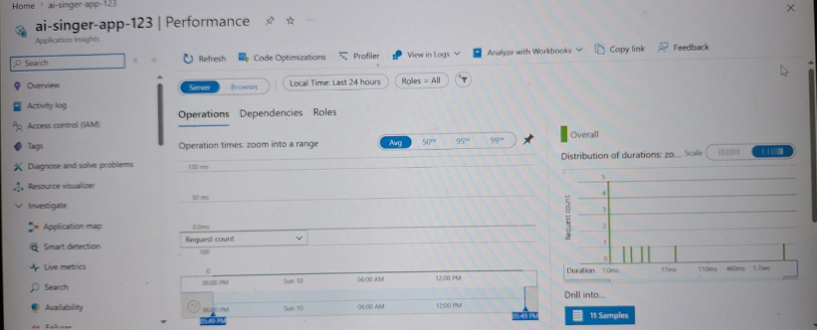
Figure 2. Daily Cost Grap

5.4KEY LEARNINGS AND TEAM CONTRIBUTIONS

Throughout the development of the AI Based Raga and Thala Music Generation System, the team gained valuable experience in cloud computing, AI integration, DevOps practices, backend architecture, and collaborative software development. One of the major learnings involved managing cloud-native deployment workflows using Microsoft Azure services combined with Docker, Terraform, and GitHub Actions.
The project provided practical exposure to AI integration using Google Gemini Pro API and Suno API. The team learned how to design structured prompts, coordinate multiple AI services, manage API orchestration, and integrate AI-generated outputs into a scalable application workflow. Implementing custom thala note spacing logic also improved understanding of rhythm synchronization and backend algorithm design for music-processing applications.
Another important learning experience came from implementing CI/CD pipelines and Infrastructure as Code (IaC). GitHub Actions automated deployment workflows, while Terraform enabled reproducible and consistent cloud infrastructure provisioning. The team also gained experience in containerization, auto-scaling, monitoring, and cloud resource optimization using Azure Container Apps and Azure Monitor.
The project strengthened the team’s understanding of scalable backend architecture and modular service design. Separate backend modules were developed for swara generation, rhythm synchronization, AI orchestration, storage management, and frontend communication, enabling easier debugging, maintainability, and future scalability.
In terms of teamwork and collaboration, the project followed an organized development workflow using Git branching, pull requests, shared task allocation, and regular progress discussions. Team members contributed across frontend development, backend APIs, cloud deployment, AI integration, and database management. Continuous collaboration and coordinated development practices improved communication, technical problem-solving, and overall project management skills throughout the implementation lifecycle.

CHAPTER 6 - CONCLUSION AND FUTURE WORKS

CONCLUSION
This project successfully delivered an AI-powered Raga and Thala Music Generation System designed to support beginner singers, music learners, and independent artists through intelligent swara generation, rhythm synchronization, and AI-based music creation. By integrating Google Gemini Pro API for swara generation and Suno API for AI music generation, the platform successfully addressed the challenge of providing accessible, interactive, and technology-driven music-learning support. The system enables users to select ragas and thalas, generate rhythm-synchronized swaras, listen to AI-generated songs, and practice singing through guided musical outputs.
The technical implementation demonstrated effective use of modern cloud-native technologies, AI integrations, and DevOps practices. Backend services deployed through Azure Container Apps provided scalable and efficient API execution, while Docker-based containerization and Terraform Infrastructure as Code enabled automated and reproducible cloud deployment. GitHub Actions automated the CI/CD workflow, simplifying backend deployment, frontend publishing, and infrastructure updates. The custom thala note spacing logic implemented within the backend successfully synchronized generated swaras according to rhythmic beat cycles, ensuring musically structured outputs.
From a user perspective, the platform provides significant value by simplifying music learning and improving accessibility to AI-assisted singing practice. Beginner singers can generate swaras, hear AI-generated songs, and follow lyrical guidance while practicing rhythm and melody. The combination of AI-generated music and cloud-based scalability creates an interactive ecosystem that supports self-learning, experimentation, and musical creativity in a user-friendly environment.
This project also provided valuable practical learning experience across multiple technical domains including AI integration, cloud computing, backend development, DevOps automation, container orchestration, monitoring, and scalable deployment management. The development process improved the team’s understanding of API orchestration, rhythm-processing algorithms, cloud-native deployment strategies, CI/CD workflows, and collaborative software engineering practices. Overall, the project successfully achieved its primary objectives while establishing a strong foundation for future AI-powered music-learning innovations.

FUTURE WORKS

The current implementation provides a strong and scalable foundation for several future enhancements focused on improving AI singing quality, expanding music-learning capabilities, and increasing personalization within the platform.

Short-to-Medium Term Enhancements

Custom AI Singing Model
A major future enhancement involves replacing the currently integrated trial-based Suno API with a custom-trained singing model. The existing audio model experienced underfitting due to limited training data and long audio training durations. Future development plans include training advanced AI singing models using larger datasets and deploying them on third-party GPU servers connected through Microsoft Azure infrastructure.

Real-Time Voice Assistance
Future versions of the platform will include real-time voice analysis and singing correction features. Users will be able to sing along with generated songs while the system analyzes pitch accuracy, rhythm synchronization, pronunciation, and tonal correctness to provide live feedback and improvement suggestions.

Personalized Music Recommendations
The platform can be extended with intelligent recommendation systems that suggest ragas, thalas, practice exercises, and song snippets based on user learning behavior, preferred music styles, and practice history.

Advanced Rhythm Visualization
Future updates may include graphical rhythm visualizers and interactive thala animations that help beginners understand beat cycles, note alignment, and rhythmic timing more effectively during practice sessions.

Long-Term Vision and Expansion

Multi-Language and Multi-Genre Support
The long-term vision includes supporting multiple Indian languages, lyrical formats, and additional music genres beyond classical music. This would make the platform accessible to a larger audience and support diverse regional music-learning requirements.

Cloud-Scale AI Audio Infrastructure
Future architecture improvements may involve deploying dedicated GPU-based AI audio processing infrastructure using Kubernetes orchestration and distributed cloud deployment models for faster and more advanced AI music generation.

Community and Collaboration Features
The platform may also evolve into a collaborative music-learning ecosystem where users can share generated songs, upload practice recordings, participate in AI-assisted competitions, and collaborate with other learners and musicians through cloud-based music communities.

Mobile and Cross-Platform Expansion
Future development plans include creating dedicated Android and iOS applications to improve accessibility, mobile learning support, and real-time music practice from any device or location.

APPENDICES
Appendix A – Terraform Code Snippets
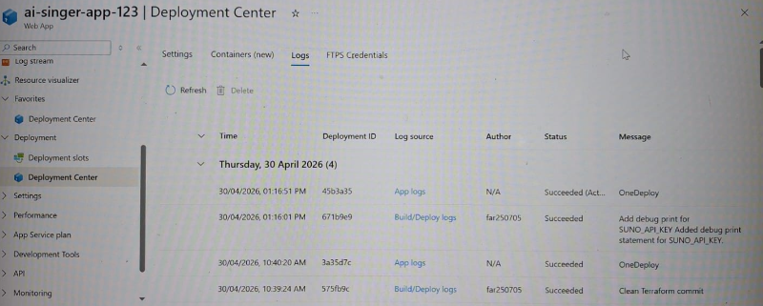

Figure 3. Deployment center

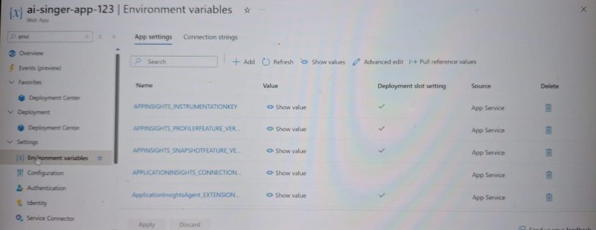

Figure 4. Environment variables

Appendix C – Screenshots (Deployments, AI Integration, Security Scans)

Successful ci/cd run:
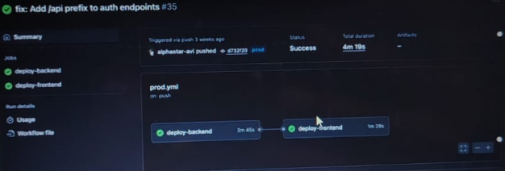

Figure 5. Workflow Showing Frontend and Backend Successfully Deployed

Integrated AI services:

1. Google Gemini Pro API
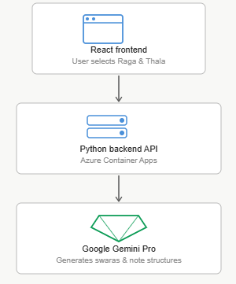
Figure 6. Gemini Pro API — swara generation flow

2. Suno AI music generation API

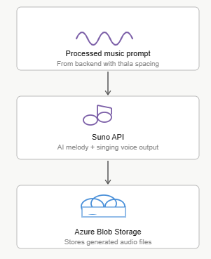
Figure 7. Suno API — music generation & storage flow

3. Azure PostgreSQL database
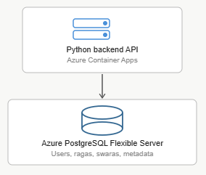
Figure 8. Azure PostgreSQL — data storage

4. Custom GPU singing model (future)
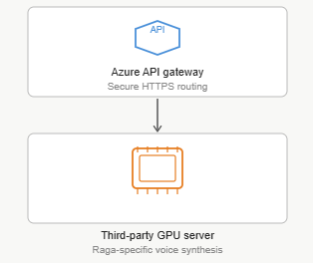
Figure 9. Custom GPU singing model — future integration

Deployment resource visualizer
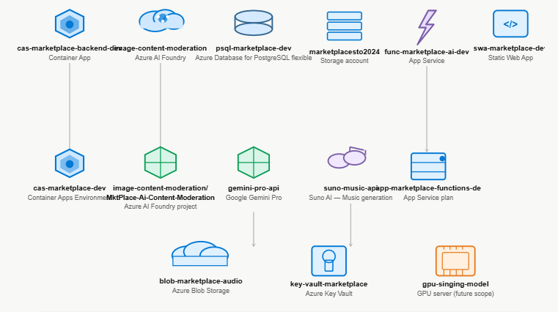
Figure 19. AI Based Raga and Thala Music Generation System — Azure resource architecture

